*Article*

Waukesha Stem Academy, Waukesha, WI, USA Google Science Fair 2015 Journal of Robotic Exosuit Research

**Increased Strength and Reduced Fatigue: Soft Upper Body Robotic Exosuit**

**Vinesh V. Janarthanan, Luke R. Selberg**

**Abstract**

*The leading cause to a disability in a muscle is stroke. Stroke affects 795,000 people just in the United States,* *while 15 million people face it in the rest of the world each year. Stroke is a very serious problem and may be fatal [1]. This is an inherited disease that occurs in the brain. Anyone affected with stroke may have a case of paralysis or muscle weakness in the lower and upper limbs*. *This means that they have reduced function or no function in those limbs compared to the average human being with a normal physiology. How can these humans be rehabilitated to restore their functionality? How can we create a cost effective solution that will be able to restore the function of the disabled? We present the soft upper limb, including its design and evaluation.*

**Keywords**

Exosuit, Soft Exosuit, Rehabilitation, Stroke, Upper limbs

**1. Introduction**

In modern technology world today, we can see how far scientific technologies have had exponential growth in the last 10 years. Yet, still human being still don’t know have to attach machines to themselves. We still are only able to carry a load based on how much weight our biological limbs can withstand. Why can’t we lift heavier weights easier? What is stopping us from doing so?

The solution for this type of weakness or disability is an assistive exoskeleton. Exoskeletons are new and emerging technology and are not available for public use yet. There is still a lot of testing and prototyping that needs to be done in this field in order to ensure securing, assist, and most importantly comfort for the end user. An exoskeleton is an external feature/device that supports and protects the movement of the joints and muscles.

Today exoskeletons are being used for the military, the elderly, the disabled, first responders, and also for people who are performing athletic activities. People in the military experience lots of fatigue while running, jumping, and carrying weapons. Exoskeletons solve this problem by letting those people experience less fatigue while letting them do what they want. Powered exoskeletons allow them to output more force in their muscles allowing them to lift more weight easily, without experiencing much fatigue. This type of technology can also be applied to the people with reduced or no function of their muscles at all. Some exoskeletons even give them the full rehabilitation of the function of the muscles.

**2. Soft Upper Limb Assistive Exosuit Proposal**

*2.1 Hard Exosuit vs. Soft Exosuit*

Previous solutions to actuate the lower and upper limbs for rehabilitation devices have been robotic exoskeletons, these types of exoskeletons are known as hard exosuits. Hard Exosuits have been around for a while but just recently scientists and bioengineers are finding solutions to tie the loop between the brain and the Robotic suit. These type of suits are typically metal, wood, or plastic. Usually the hard material goes along your limbs or body parts to give more assist/support to those limbs. These exoskeletons serve their purpose, yet they have many disadvantages. The suit itself might be uncomfortable. Rigid exosuits are heavy and restrict biological movement of the limbs. Soft -Exoskeletons is very new technology and not much information about it has been released on the internet. There are a few studies about this currently being done. Soft exosuits tend to be more comfortable and it is more flexible to be able to respond to the natural users motions. The reason they are called “soft suits” is because they are more user friendly than the rigid/hard exosuits. Finally one main reason soft exosuits are better than hard exosuits is because of the visual aspect. Hard exosuits have giant metal bars running back your limbs, while the user friendly soft exosuit is hidden under the cloths and applies force to the limb when need.

*2.1 Idea Proposal*

Exosuits work in parallel with a person’s muscles and tendons, applying muscle like torques to joints, to reduce fatigue and metabolic cost of actions. Exosuits sense and calculate a user’s intent, so that actuation systems can assist biological muscles. Hard exosuits (Rigid suits that use materials such as metal, wood etc.) have been created throughout the past, but these suits are heavy (hence causing fatigue with high interia), joints are restricted by external rigid structures and they interfere with a human’s natural biomechanics. Throughout human history we have never been able to figure out how to connect objects to the body, i.e. shoes still give us blisters. Soft exosuits are a relatively new area of science, these soft suits are extremely light and have little inertia minimizing the unintentional interference with a human’s natural body mechanics. These suits also are small and compact, able to be worn under a shirt/pants, unnoticeable to others, while being comfortable. All of these advantages cause a greater synergistic interaction with the wearer. Harvard University is currently working with the Wyss Institute to create a soft lower body exosuit to reduce muscle and tendon fatigue. While beginning the research for this project we emailed Harvard for information about their project and researched the anatomy of the arm, specifically the biceps and the triceps. We our proposing to create a light weight and soft exosuit to beneficially augment a humans upper body. This model will demonstrate the concept that soft exosuits can positively affect a human’s natural biomechanics. Exosuits can be used to strengthen and add endurance to able-bodied people, such as soldiers, firefighter, paramedics, etc. as well as to assist the elderly and rehabilitate children and adults with physical disorders, while reducing fatigue.

Current research in the field of biomedical science and bioengineering needs to be expanded, we are experiencing the age when machines will make humans stronger. Prosthetic legs should not be made without active assistance (no type of actuation or muscle assistance), because they fail to emulate muscle function; prosthetic legs should be actively powered providing assistance to the wearer. No human has the right to be physically disabled, new innovative technology such as these soft exosuits have the potential to remove preexisting technologies, such as wheel chairs, and bring full rehabilitation. Exosuits apply torques and powers at calculated time so that the users muscles need not apply those torques and powers. A common misconception about exosuits is that it is only for people dealing with week muscles or disabilities. Even people with normal physiology can wear an exosuit. The elderly are an example of people with reduced muscle and tendon function. Soft exosuits fit their need perfectly, a lightweight, soft and user-friendly suit that is small and can be worn unnoticeable while increasing strength. The military needs technology like this, the limitations of the human body is holding them back; soldiers are constantly training to increase their physical strength. The potential for this technology is really, enormous.

* Military
* Recreational use
* Rehabilitation
* Elderly
* First Responders
* Ship and factory workers
* Enhanced athletic activities
* Increased Endurance
* Reduced Fatigue
* Terrorist Response (Rehabilitation of limbs)
* Construction Workers

**3. Researching Soft Exosuit Design’s**

While beginning the research for this project we emailed Harvard for information about their soft lower limb exosuit project and researched the anatomy of the arm, specifically the biceps and the triceps. We designed the soft exosuit on the upper body because this part of the body is the easiest to mimic, this project will demonstrate that a soft exosuit can positively augment a humans natural biomechanics

*3.1 Anatomy of the Arm*

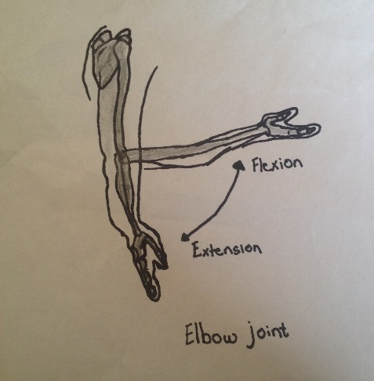The arm can swing in 180° because of the pulling and lifting strength of the upper arm. The bicep contracts while the triceps relaxes creating the motion called elbow flexion, or bending the elbow and raising the forearm. On the other hand, the triceps contracts and the bicep relaxes creating the motion called elbow extension, or straightening your elbow. The biceps is attached to the bones of the arm by tough connective tissue called tendons. Throughout the making of our soft upper body exosuit we researched and studied theanatomy of the arm in order for the exosuit to mimic the biological muscles as closely as possible in order to maximize the reduction of fatigue and metabolic cost of actions. In order for the exosuit to add strength and reduce fatigue, it should perform/mimic the exact action as biological muscles.

*3.2 Physic/Strength of the Arm & Exosuit*

Designing the soft exosuit required analysis of the upper body’s muscles. To achieve this, we drew a free body diagram of the upper body, to determine the strength our actuation system needed to exert. We also drew a free body diagram of a human beings natural biomechanics, with only natural muscles.

Dc

Fb

Da

Fa

Fc

Fa = Load

Da = Distance from elbow to load

Fb = Force of actuation system

Fc = Upward force of actuation system

Dc = Distance from elbow to actuation system

θ

∑Torques = 0 = Fa Da - Fc Dc (Sum of torques must equal zero)

Fa Da = Fc Dc (Torques of actuation system must equal torques of load)

To determine upward force of actuation

system trigonometry is needed.

Fb

Sinθ = Fc / Fb

θ

Fc

Dc

Fb

Fb Sinθ = Fc

Fa Da = Fb Sinθ Dc

Fa = (Fb Sinθ Dc) / (Da) (The load a person wearing this suit can carry is equal to (Fb Sinθ Dc) / (Da))

This formula is applied to our three actuation prototypes, explained later in the article. This formula allows us to calculate the force the system needs to exert, to lift a certain amount of weight.

***Physics of the Arm***

Here if we take a look at our arm it has many muscles that allow it to move in nearly any direction it wants. We call this having 7 degrees of freedom. One of the reasons that our biological biceps are not able to lift much weight is due to the physics of how it is. If we take a look at our bicep muscle that enables us to contract our elbow it look like this:

Humerus

Bicep Branchii

Fulcrum

Fulcrum

Radius/Ulna

Positive and Negative Torques

Force

Center of mass

1

d2

d1

Load (Mg)

d1 - d3

d3

The data shows the force the muscle has to give for every 5 pounds. For this data we used 4cm for d3 , 35cm for d1 , and the weight of the forearm as 3 pounds. After calculating for every 5 pounds, this was our data:

|  |  |
| --- | --- |
| Weight Lifting | Force of Muscle |
|  |  |
| 5 | 48.875 |
| 10 | 92.625 |
| 15 | 136.375 |
| 20 | 180.125 |
| 25 | 223.875 |
| 30 | 267.625 |
| 35 | 311.375 |
| 40 | 355.125 |
|  |  |
| 45 | 398.875 |
| 50 | 442.625 |
| 55 | 486.375 |
| 60 | 530.125 |
| 65 | 573.875 |
| 70 | 617.625 |
| 75 | 661.375 |
| 80 | 705.125 |
| 85 | 748.875 |
| 90 | 792.625 |
| 95 | 836.375 |
| 100 | 880.125 |

Given that the length of the distance from the elbow the weight is 35cm, and the forearm weighs about 3lbs we were able to theoretically calculate the force of the bicep based off the load weighs. So looking at the line on the graph and the data table we can say that the data was linear.

*3.3 Researching Actuation Schemes*

Throughout the researching of a humans natural biomechanics, we came upon 3 different types of actuation for a soft exosuit to assist a wearer’s biological muscles and tendons. These actuation systems are all easily accessible and fall under our $100 range.

|  |  |  |
| --- | --- | --- |
| **Type of actuation** | **Advantages** | **Disadvantages** |
| Pneumatic Muscles | Mimic biological muscles  Easy to use/attach | Air tank takes up space  High noise  Visual is awkward/not aesthetically pleasing |
| Pneumatic Linear Actuator | Can be placed on back  Strong, can lift high loads | High price  Required to be large so output force is high enough  High Noise  Air tank takes up space |
| Cable Driven Actuation (Motor driven) | Takes up little space  Low sound profile  Hidden under clothes | Housing/containment of cable  Proportional control  Requires high torque motor |

These actuation systems are all used and evaluated in separate exosuit prototypes explained later in the article.

*3.4 Researching Sensor Systems*

In the modern day scientist are finding more and more ways to understand the human body. In order for an exosuit to properly function it must understand when to actuate so it can positively assist biological muscles. The exosuit must transmit forces at the right times for the wearer, creating the need for sensors. Rigid exosuits usually include sensors such as encoders and potentiometers to calculate the intent of the user, but these sensors do not fit within the parameters of a soft suit, flexible soft sensors must be used to receive input from the wearer. We researched different ways of receiving input and came up with two different types of sensors.

|  |  |  |
| --- | --- | --- |
| **Type of Sensor System** | **Advantages** | **Disadvantages** |
| EMG | Painless  Reliable (Accurate)  Measures muscles -electrical activity | Requires electrode  Requires Arduino |
| Soft Flexible Sensor (Similar to Harvards) | Painless  Reliable (Accurate)  Measures muscles -movement | Requires complex software  Does not get information -from the nervous system  Hard to calculate users intent |

After performing research into different sensor designs, we concluded that EMG sensors were the best sensor system. This is because easy proportional control is achieved because data is received straight from the nervous system, which actually controls a person’s muscle. Flexible sensors placed on the surface of a person’s body were not suitable for this design because they do not detect that a user wants to move, until the person actually does move. This creates the process of calculating the user’s intent extremely difficult.

**4. Prototyping/Preliminary Design Process**

*4.1 Prototype #1*

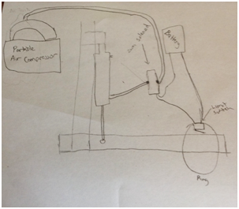Our first prototype was a hard Exosuit design. This design consisted of two wooden bars that went beside the arm. The two wooden bars were connected by a hinge and that acted as the secondary joint. This enabled the user to restore the original function of the elbow, being able to restore the one degree of freedom at the elbow pitch. After the wooden from then the pneumatic linear actuator was able to provide support for the bicep and triceps by moving the elbow up and down. After building this design we presented it to one of our teachers and then they commented on our Exosuit by saying, “Bringing back captain hook?”. That message from our teachers motivated us to come up with new, better, and innovative Exosuit designs. This design was not such a good idea because it was it centralized its focus on rigid and hard Exosuits.

*4.2 Prototype #2*

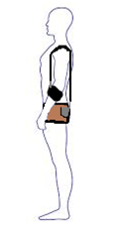Our second prototype was our first soft Exosuit prototype with cable driven actuation. This design consisted of a belt with back pockets, motor, jag wire, strap for the arm, and battery. For this idea we would have the belt around our waist and then the motor and battery in the back pocket. Then the bicycle jag wire cable will go over and around our shoulder, acting like a pulley, pulling our arm up with the rotation of the motor. So the question we needed to answer was how we decrease the speed using gears. If we have a small gear that is being actuated and a large gear with more teach that rotates proportionally then that will produce high torque. Our plan for this was to actuate the small gear and then wrap the cable around the shaft of the bigger gear. This allowed for the tension to be put on the cables and when muscle is not used then the motor would not be actuated and there would be slack in the cable. The way we came up with this idea is from Harvard University’s soft Exosuit for walking. After seeing and reading Harvard’s research papers we were inspired to apply their technologies into our Exosuit. They had done the same type of actuation. Although this was our best idea, the reason we were not able to do this design was because of the cost, the motors and all of the circuitry would just take us on the wrong path and also result in an affordable cost.

*4.3 Prototype #3 (Final Design)*

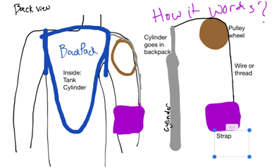Our final prototype is a hybrid of prototype one and prototype two. We take the linear actuation idea and also the cable actuation over the shoulder idea and then combine those two to come up with an affordable, easy to build, and a working prototype of the first soft upper body Exosuit. How it works is the user wears a backpack with the air tank, air cylinder, 5 way solenoid, and battery. Those parts are for the actuation system. When power is given to the solenoid then it releases the air from the air in to the room and the cylinder. Then the cylinder contracts, putting tension on the bicycle wire and forcing your arm to go up.

**5. Proof of Concept/Results**

*5.1 Testing Methods*

There are many ways to test if an exosuit works. First we realize that an exosuit reduces fatigue, increases strength (puts less strain on biological muscles). So the physical aspects that are represented in our body that we tested were the heart rate the neurological signal that is sent to the muscles. Well, we have used surface electromyography (EMG) to measure the amount of neurological signals that are sent to the muscle. EMG is used in a variety of testing in the medical field. It is used as a research tool as studying kinesiology (study of humans and animals movements and their function), also used to identify neuromuscular disease, and in prosthesis. How we incorporate this in our soft exosuit is only for the testing stage. We compared the raw surface electromyography of our bicep without the soft exosuit and also compared it with the exosuit. With this data we can determine how much neurological signal is being transmitted to the arm with the exosuit and without the exosuit. Our goal is to reduce the neurological signal while the force on the bicep gets heavier. This means that the bicep wouldn’t have to work as hard because of the support from the suit.

*5.2 Testing – EMG Scanning*

The EMG scanning results was a major success. The graphs clearly showed that our soft exosuit adds strength to biological muscles. Control tests and multiple trials were performed for each test ensuring correct data. Our soft exosuit allowed a person lift 60 lbs effortless with system pressure of 80 PSI and 110 lbs at a system pressure of 150 PSI.

The exosuit mimicked the bicep perfectly, and EMG graphs showed how the bicep muscle had to work less than it usually did to pick up a certain amount of weight. EMG measures the muscles response to a nerve's stimulation of the muscle. The EMG graphs showed that the nervous system did not have to send signals to biological muscles, the exosuit was lifting the weights for the body, or in other words, the exosuit was appling muscle like torques so the users biological muscle needed not to apply those torques.

The results of this experiment proved that soft exosuits can perform the same function as hard and rigid exosuits, but with less materials, lower space, and less cost. The future world could be changed with this finding. Comfortable suits, able to be worn under clothes unnoticable, while increasing the strength and effiecency of the user. Small, compact and easy to use technology that has the potential to be used in a humans daily life.

The EMG is recorded by using an electrode at where the nerve meets the muscle, then the electrical activity in your body is measured. Raw EMG is EMG in its purest form. The reason scientists and many other people don’t use raw EMG is because raw EMG contains the unwanted electrical signals such as signals possibly from outside the body. Also the electrodes move and that may be a problem. Rectification is the translation of raw EMG to a single polarity sequence. The reason we need to rectify the EMG is because the raw signal does not average to zero, because the raw EMG has a positive and negative polarity. There are two types of rectification of the signal which refers to what happens to the EMG when it is processed. The two different types are full length frequency and half length frequency. The full length frequency adds the negative polarity to it, which is located below the base line to the signal above the base line making a conditioned signal that is all positive.

The EMG scanning results was a major sucsess. The graphs clearly showed the our soft exosuit adds strength to biological muscles. Control tests and mutible trials were perfmored for each test ensuring correct data. Our soft exosuit allowed a person lift 60 lbs effortlesy with system pressure of 80 PSi and 110 lbs at a system pressure of 150 PSI according to the eqautions we wrote in the resarch section.

The exosuit mimicked the bicep perfectly, and EMG graphs showed how the bicep muscle had to work less than it usually did to pick up a certain amount of weight. EMG measures the muscles response to a nerve's stimulation of the muscle. The EMG graphs showed that the nervous system did not have to send signals to biological muscles, the exosuit was lifting the weights for the body, or in other words, the exosuit was appling muscle like torques so the users biological muscle needed not to apply those torques.

The results of this experiment proved that soft exosuits can perform the same function as hard and rigid exosuits, but with less materials, lower space, and less cost. The future world could be changed with this finding. Comfortable suits, able to be worn under clothes unnoticable, while increasing the strength and efficiency of the user. Small, compact and easy to use technology that has the potential to be used in a human’s daily life.

The EMG is recorded by using an electrode at where the nerve meets the muscle, then the electrical activity in your body is measured. Raw EMG is EMG in its purest form. The reason scientists and many other people don’t use raw EMG is because raw EMG contains the unwanted electrical signals such as signals possibly from outside the body. Also the electrodes move and that may be a problem. Rectification is the translation of raw EMG to a single polarity sequence. The reason we need to rectify the EMG is because the raw signal does not average to zero, because the raw EMG has a positive and negative polarity. There are two types of rectification of the signal which refers to what happens to the EMG when it is processed. The two different types are full length frequency and half length frequency. The full length frequency adds the negative polarity to it, which is located below the base line to the signal above the base line making a conditioned signal that is all positive.

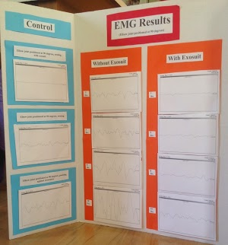

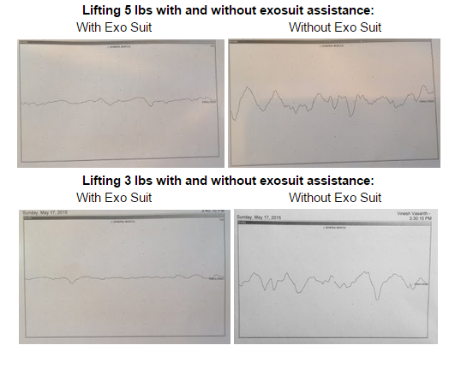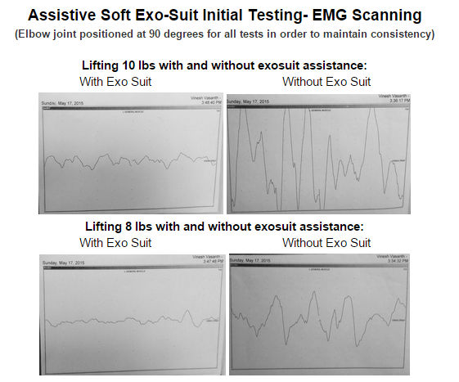

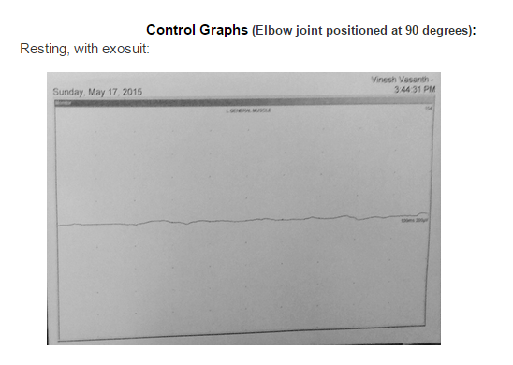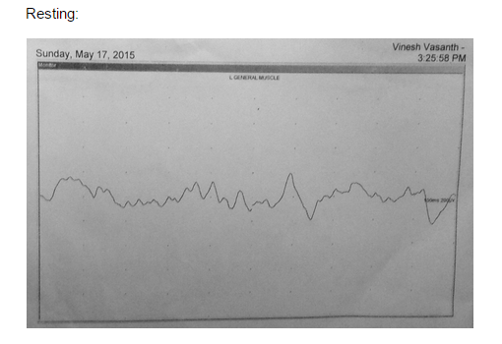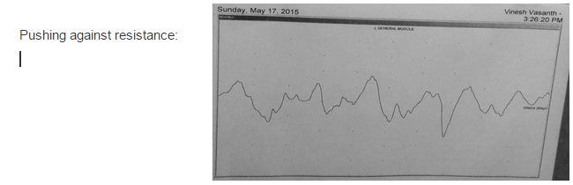

**6. Conclusion/Report**

After completing the exosuit and performing EMG scans, the results showed concrete evidence that the exosuit did support weight and positively augmented biological muscles. This data is shown more into depth in the results section. This experiment demenstrates that comfortable, lightweight and unnoticable soft exosuits can perform the same task as hard and rigid exosuits, but much more effiecently.

Our results supported our hypothesis, and solved the problem we were trying to solve. Our problem was- How can we comfortably and positively augment a human's natural bio-mechanics? This experiment showed how creating a soft exosuit actually did increase the strength of biological muscles, and could be used in the real world. Our hypothesis stated that the exosuit will mimic biological muscle and apply muscle like torques, so biological muscles need not apply those torques. EMG scanning proved that lifting weights with the exosuit required tremendously less biological muscle activity than lifting weights without the exosuit.

Further development of our project could have a huge impact on the future world. With proper funding we could create a full body soft exosuit that is lightweight and houses an electronically driven cable system to actuate joints. Electronics will allow the suit to function for large periods of time and be very lightweight. Soft exosuit technolgys are easy to use, and could be implemented into a humans dailey life unnoticable, where as hard exosuits could not. Innovative soft exosuit technolgy has huge potential. Also further research could be performed to find even more effiecent actuation schemes, and even green powered options.

Winning google science fair would be an AMAZING experience which will allow us to further develop our project. This will also allow us to publicly display our research and findings, allowing us to be able to meet experts on our topic. The prizes will allow us to use facilities, equipment, and materials that we wouldn't have had access to. Our goal is to design the future world with bionics technology for the disabled, ordianry people, factory workers, the military, and etc and potentially make the future a better place.

Some Applications of Soft Exosuit Technology:

* Military
* Recreational use
* Rehabilitation
* Elderly
* First Responders
* Ship and factory workers
* Enhanced athletic activities
* Increased Endurance
* Reduced Fatigue
* Terrorist Response (Rehabilitation of limbs)
* Construction Workers

**BIBLIOGRAPHY**

Works Cited

Ref 1:"Electromyography (EMG) in Sport and Exercise Science." YouTube. YouTube, n.d. Web. 18 May 2015.

Ref 2:"Electromyography." Wikipedia. Wikimedia Foundation, n.d. Web. 18 May 2015.

Ref 3:"How Stroke Rehabilitation Works." Regain Muscle Control after Stroke. N.p., n.d. Web. 16 May 2015.

Ref 4:"Hugh Herr: The New Bionics That Let Us Run, Climb and Dance." YouTube. YouTube, n.d. Web. 16 May 2015.

Ref 5:"Mobility Enhancing Soft Exosuit at Harvard." YouTube. YouTube, n.d. Web. 16 May 2015.

Ref 6:"Soft Exosuit." : Wyss Institute at Harvard. N.p., n.d. Web. 18 May 2015.

Ref 7:"Soft Exosuits." Soft Exosuits. N.p., n.d. Web. 18 May 2015.

**ACKNOWLEDGMENTS**

Alan T. Asbeck

Alan T. Asbeck is a Research Scientist at the Harvard Biodesign Lab and am also affiliated with the Wyss Institute for Biologically-Inspired Engineering. His job is to create robotic devices that help people move. How he helped us through our journey of this project is by thankfully letting us view their Biodesign Lab's 2012, 2013, 2014, and their 2015 research articles. We are so thankful to get a hold of him because he helped us answer many of our questions, and also without those research articles we wouldn't have learned much about soft exosuit technology.

Robert Selberg

Robot Selberg is Luke's dad. He is a mechanical engineer and works at GE. At his work he designs ways to reduce the emmitions from cars. He has helped us greatly by buying and supplying many of the primary parts we needed such as the air cylinder and the air tank. We are so thankful to have him help us because he is the one who helped with the mathematical equations. Also, when we had a question or when we were stuck then we would ask him for any suggestion. Robert Selberg

Dr. Jennifer Kennedy

Dr. Jennifer Kennedy is one of Vinesh's family's close friends. She is a Rehbilitation Physiatrist in Millwaukee, Wisconsin. Also, she is affiliated with multiple hospitals in the area, including Columbia St Mary's-Columbia and Columbia St. Mary's Ozaukee Hospital. We were very lucky to find a doctor that would be willing to do EMG for a science fair project. Here is a special thanks to Dr. Jennifer Kennedy for being able to take us into the Columbia St Mary's-Columbia Women's hospital and doing a surface electromyography scan on us. With out her we would have had absolutely no EMG resuts, infact we would have to find a different source or a different type of test.

Vasanth Janarthanan

Vasanth Janarthanan is Vinesh's dad. He is a Computer Engineer at U.S. Bank. He designs and develops software for credit cards. Because his profession was not related to our project topic, the only help that we he was able to do was buy us materials. He bought us materials and supplies for the project such as adapters for the linear actuator. We thank Vasanth Janarthanan for having faith in our project and also giving us money to buy materials.

Brian Brookins

Brian Brookins is a Science Teacher at the Waukesha STEM Academy, Saratoga Campus. His profession was slightly able to aid our project in the right direction. Our first exosuit prototype was a hard and rigid exosuit. Once he called that "Captain Hook" that then gave us lots of motivation to research and develop new designs. We thank Mr. Brookins for helping us go in the right direction in this project. He asked us many questions that made us think at deeper level about our project.

Tammy Sheahan

Tammy Sheahan is a Educational Assistant at the Waukesha STEM Academy, Saratoga Campus. Although her profession was not able to guide us through this project, her previous experiences had helped our project. She has a son that wears a brace on his leg, because of this she knows a lot about artificial limbs. Thanks to her because she was the person who made us start thinking about electrical signals to the muscles. If she hadn't helped us then we don't think that we would know what EMG was.

Conor Walsh

Conor Walsh is a Professor Assistant Professor of Mechanical and Biomedical Engineering at Harvard University. Although Conor Walsh did not scientifically help us with our exosuit, he just was able to tell us where to get resources. He told us that on their Biomedical Lab website they have information and research documents on soft exosuits. He also said good luck on this project, and that felt really good because it was cool getting help from Professors at Harvard University.

Marcella Selberg and Vanitha Vasanth

Marcella Selberg and Vanitha Vasanth are our Moms. They also did not help us scientifically with our project, but they brought us to each outhers houses to work on the project. Also they took care of us while we were working by cooking us food. They also had courage and hope in our project to win google science fair, and that was all we needed from them.

**FACILITIES**

Columbia St Mary's-Columbia Women's hospital - EMG Scanning for Results

2301 N. Lake Dr., Milwaukee, WI 53211

Waukesha STEM Academy, Saraoga Campus - Researching Exosuits

130 Walton Ave, Waukesha, WI 53186

Vinesh's House - Prototyping

2733 Fieldridge Dr Waukesha, WI 53188

Luke's House - Prototying

2813 Jacquelyn Dr Waukesha, WI 53188